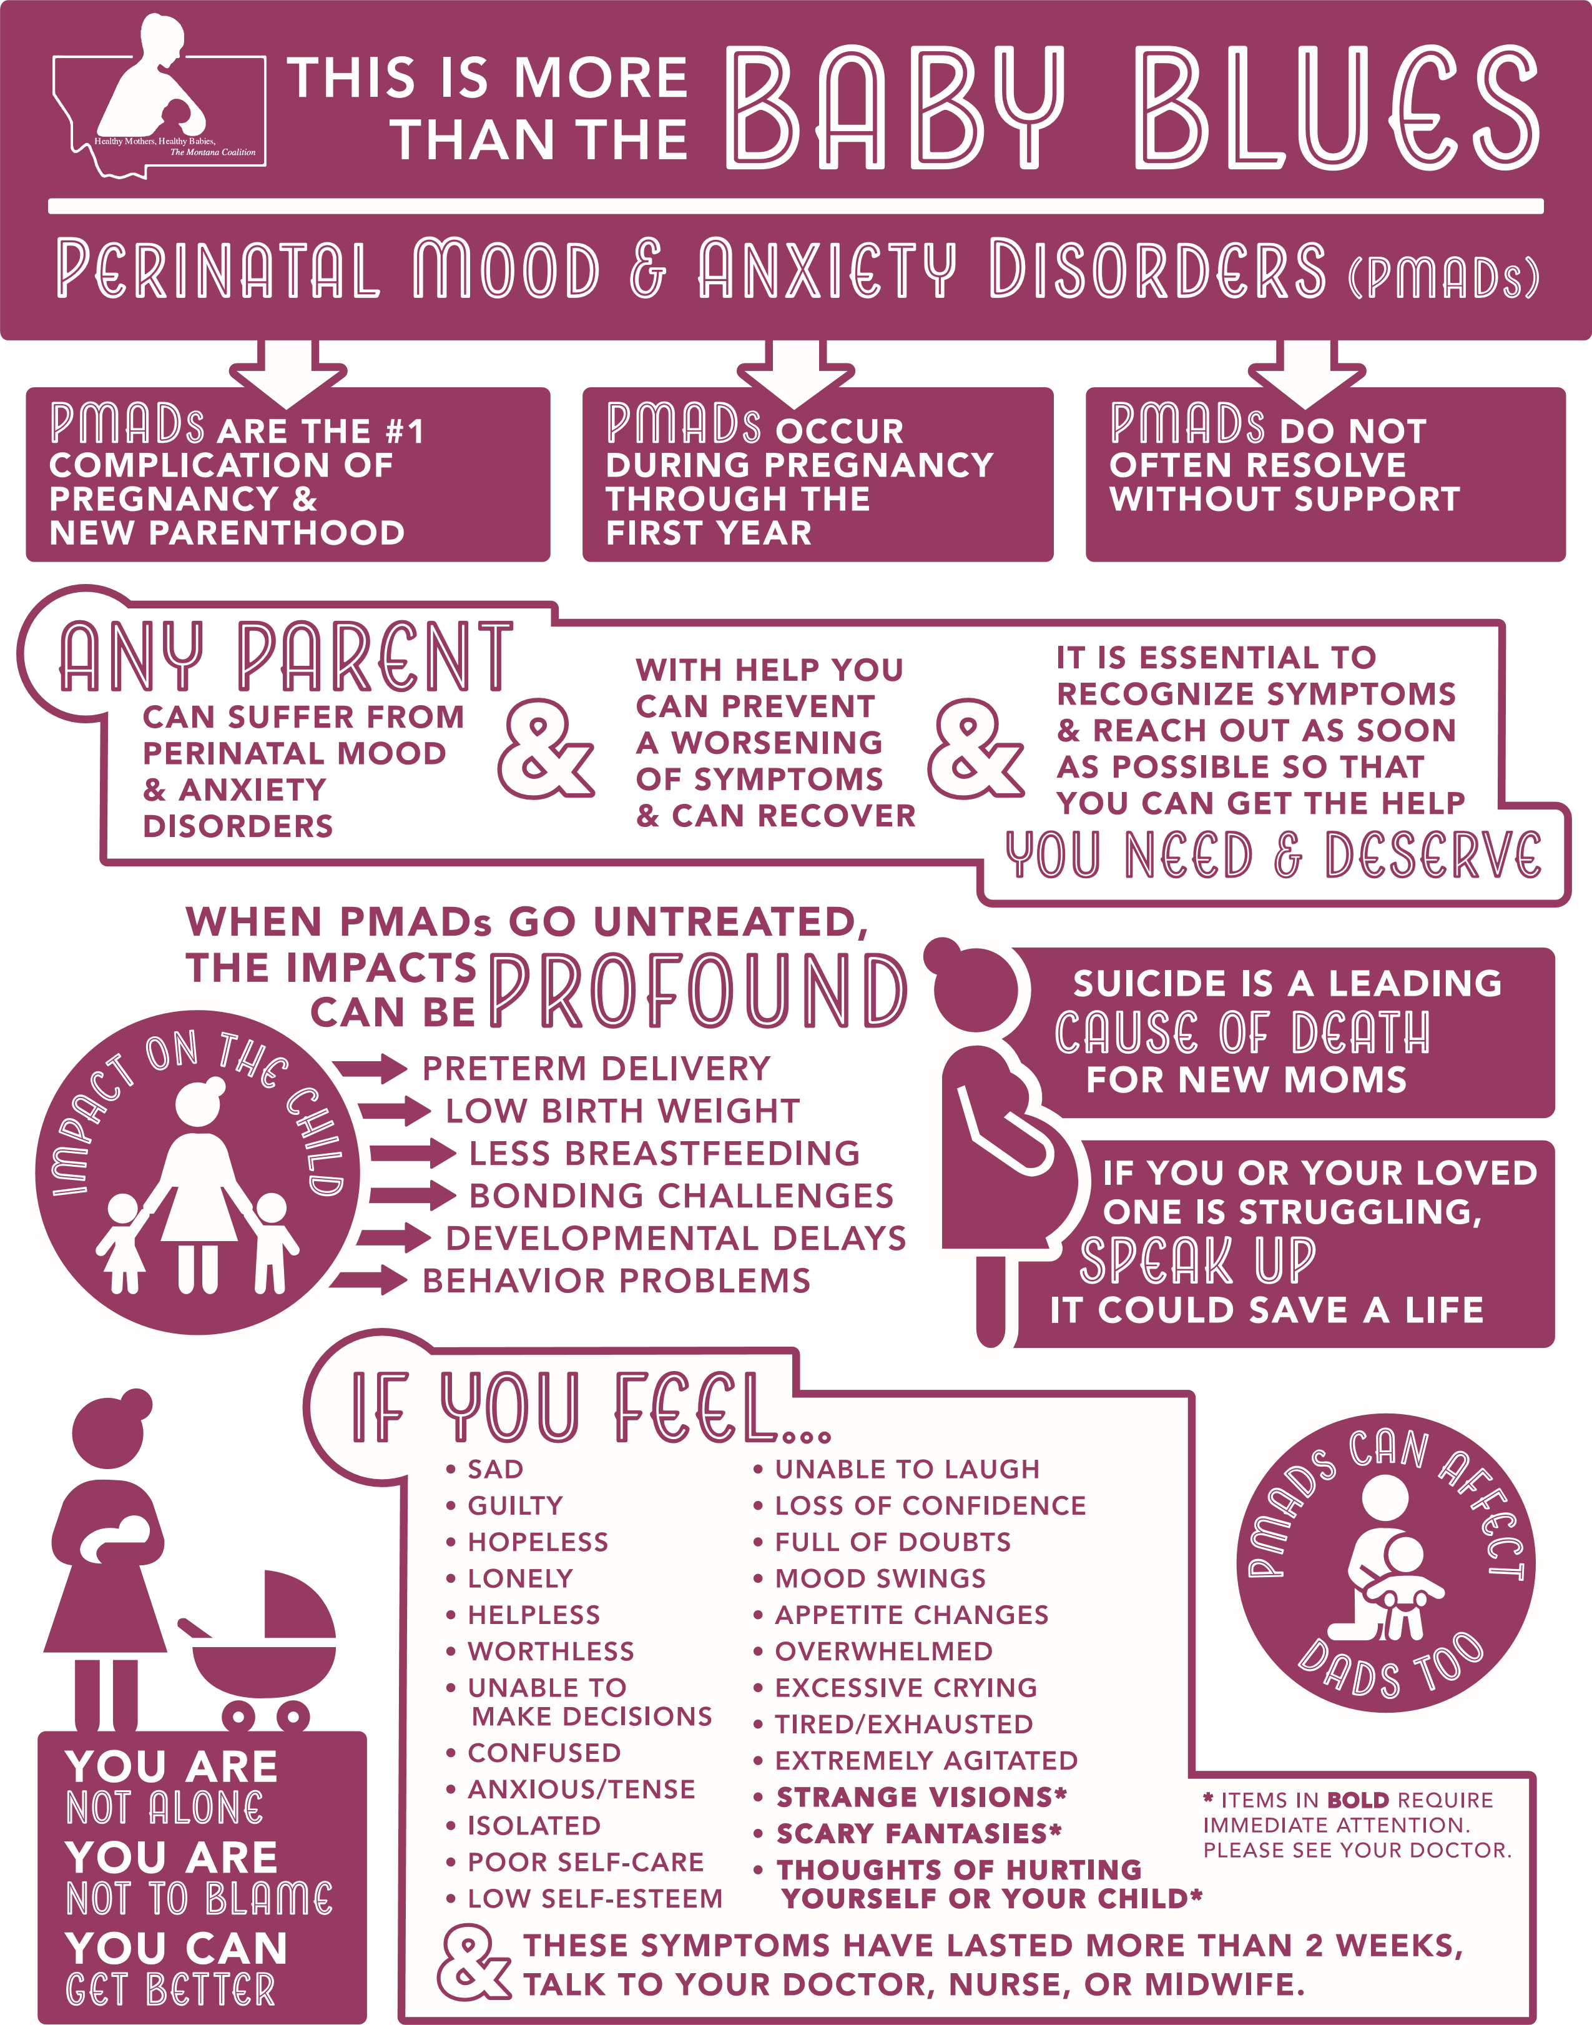



SUPPORT NETWORKS
HOME VISITING
406-444-4444 | EMAIL@ADDRESS.COM
FATHER SUPPORT
406-444-4444 | EMAIL@ADDRESS.COM
DOULA
406-444-4444 | EMAIL@ADDRESS.COM
GROUP PEER SUPPORT
406-444-4444 | EMAIL@ADDRESS.COM

MENTAL HEALTH PROVIDERS
COUNSELORS
406-444-4444 | EMAIL@ADDRESS.COM
PSYCHIATRISTS
406-444-4444 | EMAIL@ADDRESS.COM
SPECIALIZING IN DAD
406-444-4444 | EMAIL@ADDRESS.COM

MEDICAL PROVIDERS
FAMILY PRACTICE
406-444-4444 | EMAIL@ADDRESS.COM
OBGYN
406-444-4444 | EMAIL@ADDRESS.COM
PEDIATRICIAN
406-444-4444 | EMAIL@ADDRESS.COM
CERTIFIED NURSE MIDWIFE
406-444-4444 | EMAIL@ADDRESS.COM
PHYSICAL THERAPIST
406-444-4444 | EMAIL@ADDRESS.COM

BREASTFEEDING SUPPORT
PT/OT/SPEECH
406-444-4444 | EMAIL@ADDRESS.COM
CLC
406-444-4444 | EMAIL@ADDRESS.COM
LA LECHE LEAGUE
406-444-4444 | EMAIL@ADDRESS.COM
WIC GROUPS
406-444-4444 | EMAIL@ADDRESS.COM

COMPLIMENTARY &
ALTERNATIVE MEDICINE
NATUROPATH
406-444-4444 | EMAIL@ADDRESS.COM
ACUPUNCTURE
406-444-4444 | EMAIL@ADDRESS.COM
MASSAGE/REIKI/YOGA
406-444-4444 | EMAIL@ADDRESS.COM
Certified Professional Midwives
406-444-4444 | EMAIL@ADDRESS.COM

OTHER RESOURCES
LIBRARY
406-444-4444 | EMAIL@ADDRESS.COM
CHILDBIRTH COLLECTIVE
406-444-4444 | EMAIL@ADDRESS.COM
MAGAZINE
406-444-4444 | EMAIL@ADDRESS.COM
MILK BANKS
406-444-4444 | EMAIL@ADDRESS.COM

